SIMATS ENGINEERING (SAVEETHA SCHOOL OF ENGINEERING)
Course Code & Title: | ECA5604 -5G/6G COMMUNICATION | Course Faculty: | Dr.K.Sathish
Student Name: | Velamuri Bhanodhay | Reg. No.: | 192412330
Dept / Batch: | BE.ECE / 2024 | Date: | 10/8/2026
Lab Observation

Experiment 10 : 5G Network Slicing Environment Using MATLAB

Objective 1: Analyze the creation and allocation of multiple network slices in a 5G network using MATLAB.
Observe how different slices can be configured to support diverse service requirements and
applications.

Matlab Code:

clc;
clear;
close all;
slices = {'eMBB','URLLC','mMTC','Private','IoT'};
count = [1 1 1 1 1]; % One instance of each network slice
figure
bar(count)
grid on
set(gca,'XTickLabel',slices)
xlabel('Network Slice Type')
ylabel('Number of Network Slices')
title('Number of Configured 5G Network Slices')

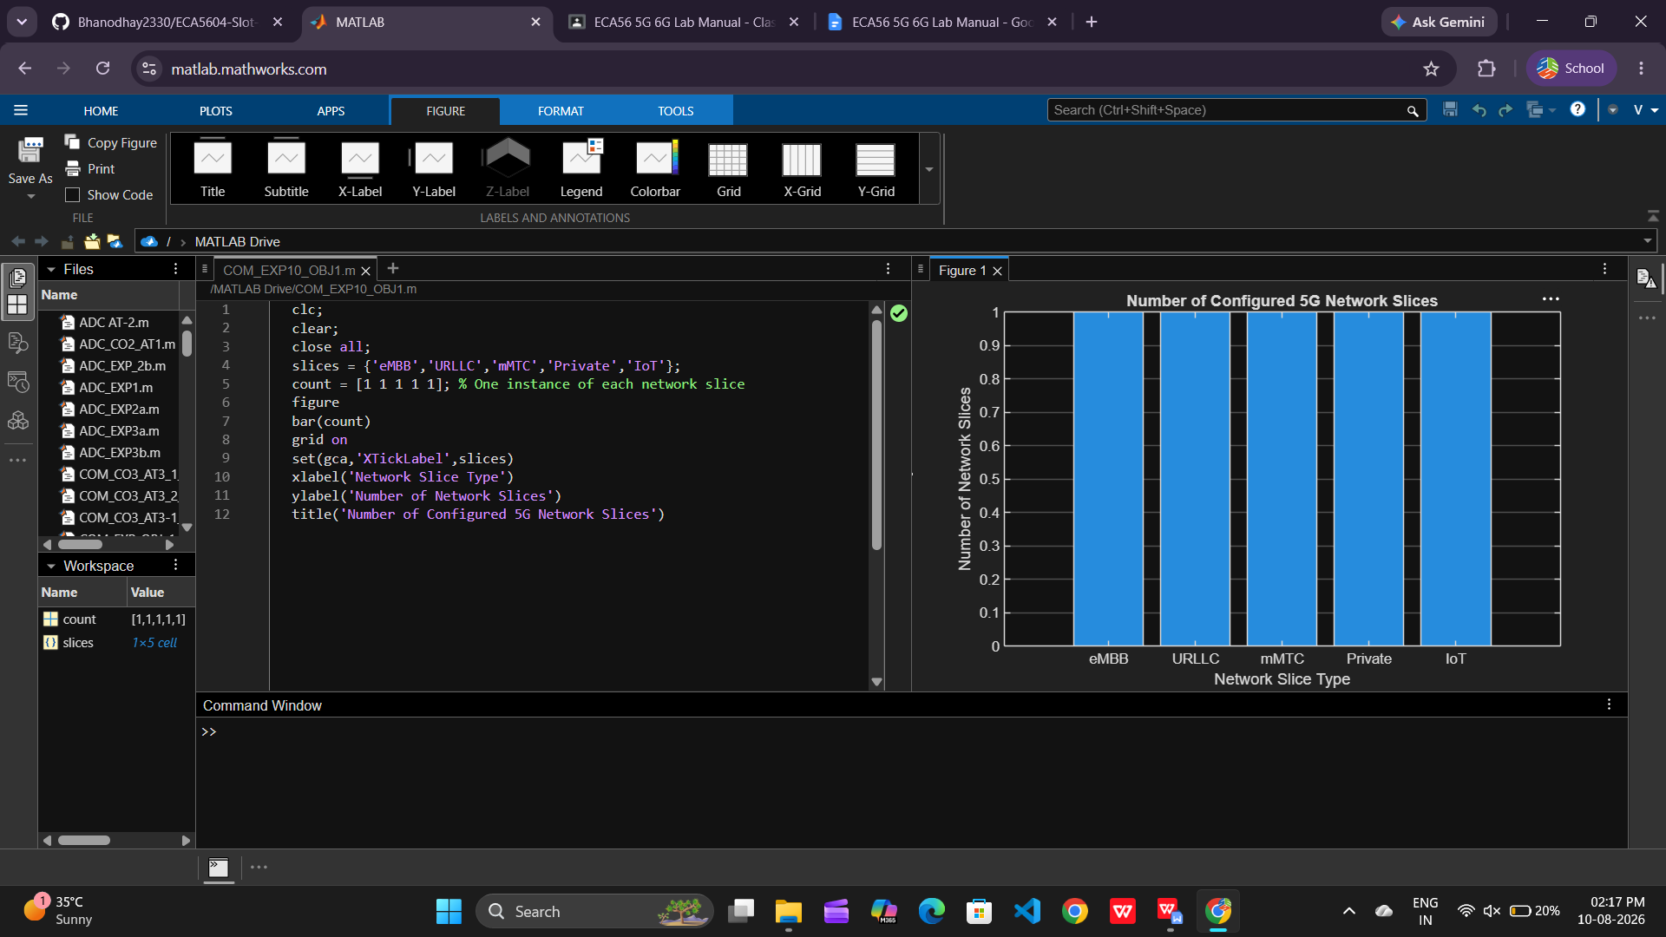

Objective 2: Compare the utilization of different network slices using MATLAB. Analyze how efficiently
network resources are allocated and utilized across multiple slices.

Matlab Code:

clc;
clear;
close all;
slices = categorical({'eMBB','URLLC','mMTC','Private','IoT'});
utilization = [85 70 60 75 50];
figure;
bar(slices, utilization);
grid on;
xlabel('Network Slice Type');
ylabel('Slice Utilization (%)');
title('Slice Utilization in 5G Network Slicing');
ylim([0 100]);

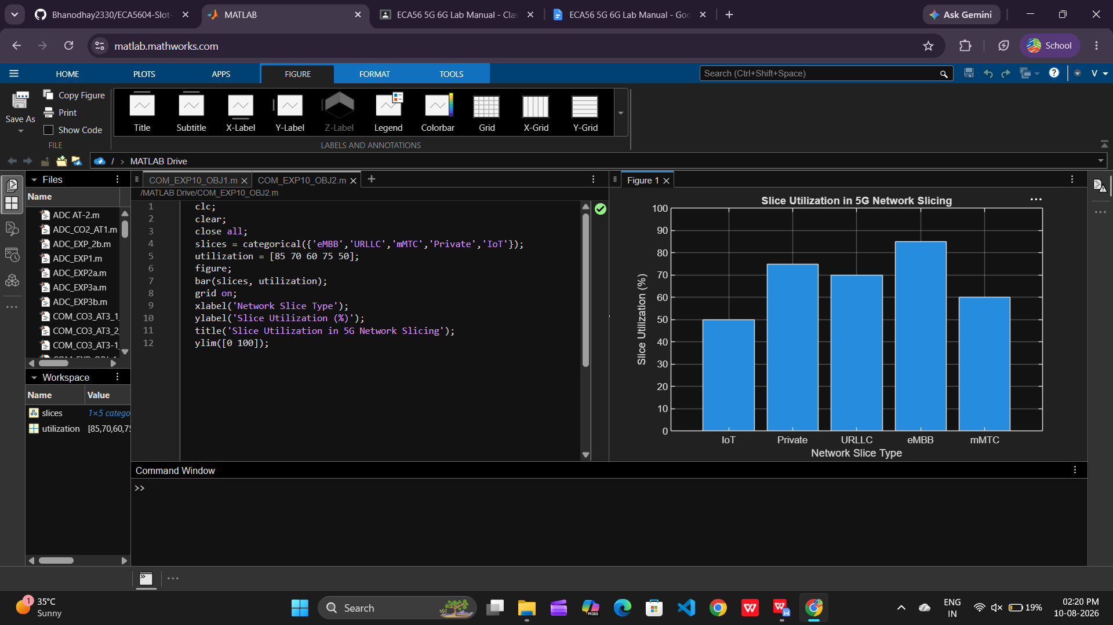

Objective 3: Analyze the end-to-end latency of different network slices using MATLAB. Compare the latency values to understand the Quality of Service (QoS) requirements of various 5G applications.

Matlab Code:

clc;
clear;
close all;
slices = [1 2 3 4 5];
latency = [25 5 40 15 60];
figure;
plot(slices, latency, '-o','LineWidth',2,'MarkerSize',8);
grid on;
xticks(slices);
xticklabels({'eMBB','URLLC','mMTC','Private','IoT'});
xlabel('Network Slice Type');
ylabel('End-to-End Latency (ms)');
title('5G Network Slicing: End-to-End Latency');
ylim([0 70]);

